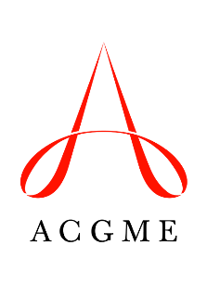
Self-Study Summary of Achievements
Department of Field Activities
Use this template to describe the strengths of the program and the improvement outcomes that were achieved in areas identified during the Self-Study.

Provide responses to the eight questions below.
The Summary of Achievements must be completed and uploaded to the Accreditation Data System a minimum of 12 days prior to the 10-year Accreditation Site Visit date.
Programs with changes in information related to aims or environmental context (opportunities and threats facing the program) may also submit a Self-Study Summary Update before the 10-year Accreditation Site Visit.

Note:
The updated information will be used to assess the effectiveness of the program’s Self-Study in promoting achievement in areas important to the program’s aims and environmental context.

Program Name: _________________________________________
Program Number: _______________________________________
Self-Study Date (Month, Year): ____________________________

Program Strengths
Question 1: List the key strengths identified during the Self-Study. (Maximum 250 words)
Question 2: Discuss how these strengths relate to the program’s aims and context. (Maximum 300 words)
Achievements in Program’s Self-Identified Areas for Improvement
Question 3: Describe improvements in critical areas identified during the Self-Study that have already been achieved. (Maximum 250 words)
Question 4: Discuss how these improvements relate to the program’s aims and context. (Maximum 300 words)
Question 5: Summarize what was used to track progress and to assess the improved outcomes. (Maximum 250 words)

Question 6: If this is a core program with two or more dependent subspecialty programs, did the Self-Study process for the dependent subspecialty programs identify common strengths, areas for improvement, opportunities, and/or threats across programs? (If not a core with dependent subspecialties, skip to Question 7).
___ Yes ___ No
If Yes, please summarize common areas identified during the Self-Study where improvements have been made. (Maximum 200 words)

Question 7: Discuss how program leadership coordinates aims and improvement priorities for the program with the priorities of the program’s clinical department/division and those of the sponsoring institution. (Maximum 250 words)

Question 8: Discuss whether and how the Self-Study and 10-Year Accreditation Site Visit added value, and summarize any learning that occurred during this process. (Maximum 250 words)

