“Messy” Desk Exercise

This is a picture of the desk of a typical busy clinician-educator. Jot down your own version of your educational activities in the boxes below, as appropriate.
Teaching principles or articles you love:
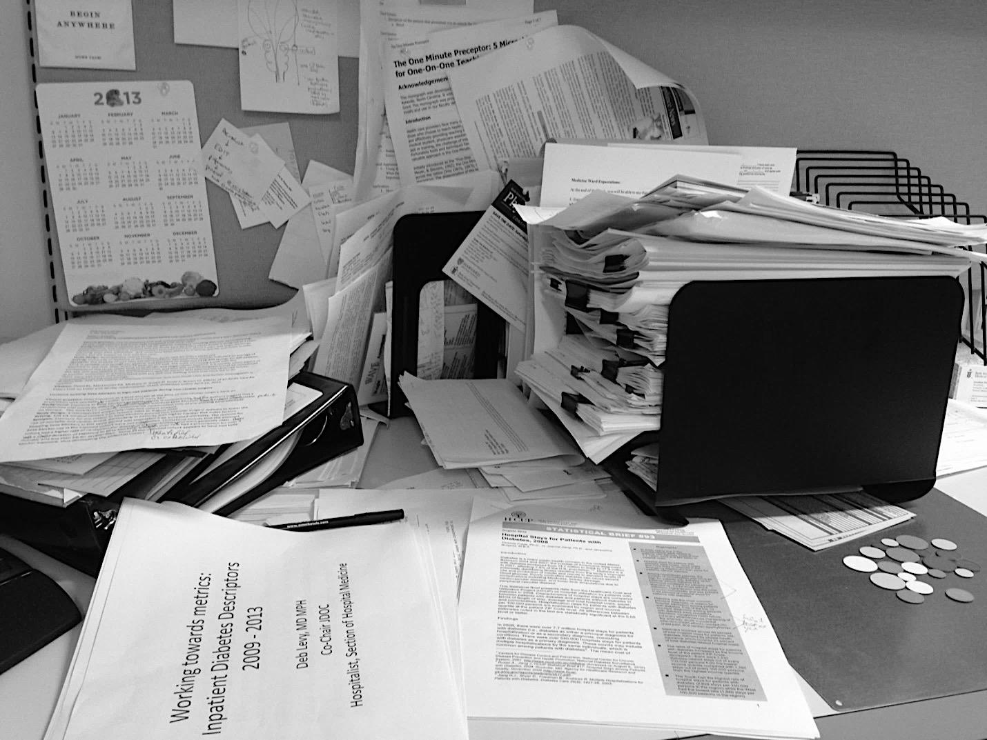
Societies you are part of:
Workshops you have given:
Curricula or tools you are designing:
Manuscripts in draft:
What your inner voice says to you about publishing:
Committee work:

