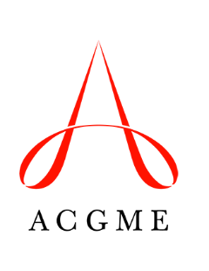
Self-Study Summary Update

Use this template to update information in the Self-Study Summary submitted to the ACGME.

Before the 10-Year Accreditation Site Visit
The Self-Study Summary Update is optional, and should be used to provide new information for the 10-Year Accreditation Site Visit.
Two types of updates can be made: 1) to identify changes in the program since the Self-Study Summary was submitted; and 2) to provide information on new dimensions of the Self-Study that were added in April 2017.
The Self-Study Summary Update is completed and uploaded through the Accreditation Data System a minimum of 12 days before the date of the 10-Year Accreditation Site Visit.
Programs must also complete the Self-Study Summary of Achievements.

Update 1: Updates/Changes to Information Provided in the Original Self-Study Summary
Use this part of the form to describe any changes or updates to the information that was submitted in the original Self-Study Summary. (Maximum 350 words)

Update 2: What Will Take This Program to the Next Level?
If the Self-Study Summary was submitted prior to April 2017, use this part of the form to provide information for areas that were added to the Self-Study Summary.
Project your vision and plans for the program for the coming five years. What will take this program to “the next level”? (Maximum 350 words)
Note: In your response, discuss what the “next level” will look like, the envisioned steps and activities to achieve it, and the resources needed.

